User Manual: zMessage Maintenance

| December-20 |

**Document Overview**

**Documentation Goals**

This documentation is intended to provide instruction for ***(creating and operating zMessages)****.*

**Documentation Disclaimers**

* Teach a user how to create a custom ***zMessage***.
* Provide definitions for the various required and optional fields when creating or editing a ***zMessage***.
* Define which fields may be accessed and edited by users defined at certain Security Levels, and which can only be edited by System Administrators.

**Table of Contents**

**Overview** 2

zMessage Field Definitions 2

# **Overview**

The creation of ***zMessages*** is limited to development efforts to allow user control over system messages. These messages allow for workflow and notification control as well as translations or terminology changes to make messages more effective.

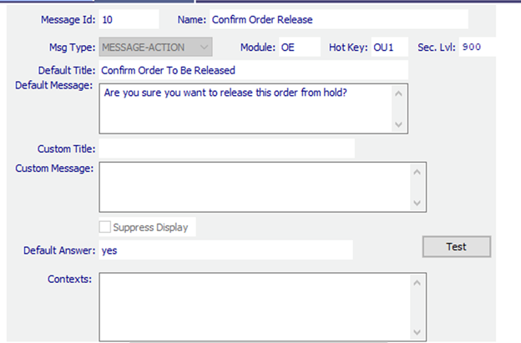

### zMessage Field Definitions

#### Message ID

This is the identification of the message in the system. The *Message ID* is not of value or significance other than clearly identifying the message that is displayed to the user, and to allow the Administrator to correctly identify and test a message when making adjustments.

***zMessages*** are added over time, are sequentially numbered, and most messages can be converted to a ***zMessage*** if desired. All new development will leverage the ***zMessage*** framework where appropriate.

The *Message ID* is always displayed at the end of any message such that it is clear which message is being utilized in the presentation, and to identify ***zMessages*** from normal messages provided to a user during operation of the application.

#### Message Name

This is the name of the message. This is for information only, and identified when the message is created.

#### Message Type

This is the message type that is linked to the message. The following message types are available:

|  |  |  |
| --- | --- | --- |
|  | Question | A prompt that requires a user decision to answer (***“Yes”*** or ***“No”***). |
|  | Warning | A warning message to be sure that the user is aware of special situation. |
| NONE | Message | A message without special notification (No Symbol). |
|  | Information | A message that for informational purposes only. |
|  | Error | An entry needs to be corrected before proceeding. |

#### Module

The module that the message applies to if focused on a single module of the system.

#### Hot Key

The hot key associated with the message if only a single hot key is applicable.

#### Security Level

The security level required to view and edit the message contents.

#### Default Title

This is the message title of the message window that will appear by default.

#### Default Message

This is the default message that will be displayed.

#### Custom Title

This is where the Administrator can adjust the default title in order to make the title more appropriate or in a different language. (*Administrator Editable*)

#### Custom Message

This is where the Administrator can adjust the default message to a more relevant or custom message for your implementation. (*Administrator Editable*)

#### Suppress Display

This is how to turn off the message from appearing. This can be used in multiple ways based on the message type.

If the message type is a ***“Yes”/”No”*** question, then if the message is not desired to give the user the option to respond, then a default answer can be entered, and the message suppressed.

For example, if the question is ‘*Do you want to update the FG item with value entered?*’ and it is a ***“Yes”/”No”*** that is displayed to the users, and the Administrator ***always*** wants the answer to be ***“Yes”***, then the default answer can be entered as a ***“Yes”*** and the message suppressed. This will just answer the message for the user and proceed to execute the response as if they answered to the affirmative, and the message will not appear.

If a message requires an answer, an answer must be provided before the message can be suppressed. This is the Administrator’s decision based on workflow or other desire. (*Administrator Editable*)

#### Default Answer

This is the answer to the question or message. It is only necessary when the message will be suppressed. If the message is displayed, the user response will be utilized in execution of the result. (*Administrator Editable*)

#### Test Button

This is a test button to view the message as the user will see it with the prompts available for the user.

#### Contexts

Some messages have the ability to embed localized context into a message. These values are pre-defined with the message and cannot be changed, but can be utilized in either the default message or the custom message.

Context Examples: Message #55

|  |  |  |
| --- | --- | --- |
| StockId | Inventory item number | Example: FG6x6x6 00001 |
| TagStatus | Inventory tag status number | Example: 001 |
| TagStatusDescription | Inventory tag status description | Example: Quarantine |
| ItemName | Inventory item description | Example: Stock ox 6x6x6 |

In the use of a message with context, the default message looks like this:

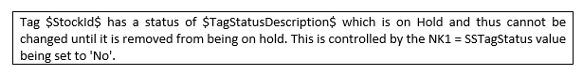

So, the message framework will replace all identified context values, so this message will display to the user as follows, with the values of the data they are working with replacing the place holders and display as follows:

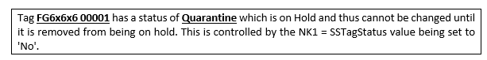

This tells the user the tag in reference, the status of the tag, and why they are getting the message. The context usage is optional and can be replaced with any text, but if the desired values should be replaced, use the context value with a preceding ‘$’ and ending the context value with another ‘$’ to indicate the placeholder should be replaced.

Each context value is specific to the message id they are identified with and are the only values that can be utilized for that message since only certain information is available at the point in time when the message is presented to the user.